Nourishing the Heart, Nurturing Change: How One Youth is Building a “HeartWise” Nutrition Culture in Bangladesh

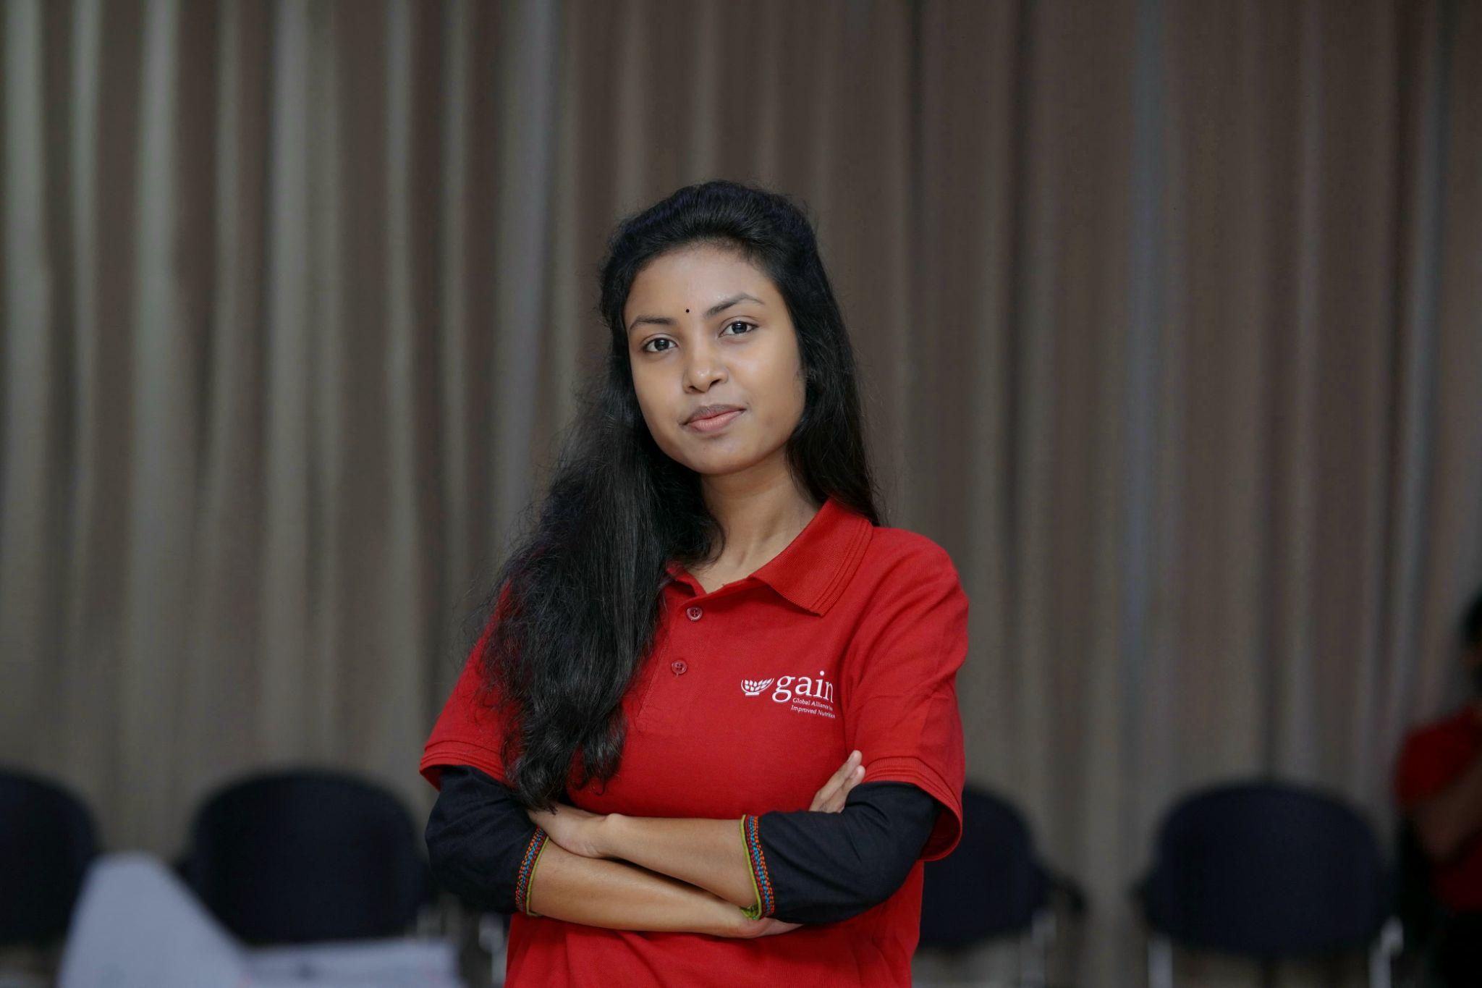

Joya’s journey didn’t begin in a lab, but around her family’s lively kitchen table, filled with discussions about food safety and what truly nourishes. "My mother would say, ‘Grow up, and do what you can.’ That stuck with me," Joya recalls. This early passion, coupled with her graduation in Nutrition and Food Engineering, found its true north when she joined the Food Systems Youth Leadership Training, supported by GAIN.

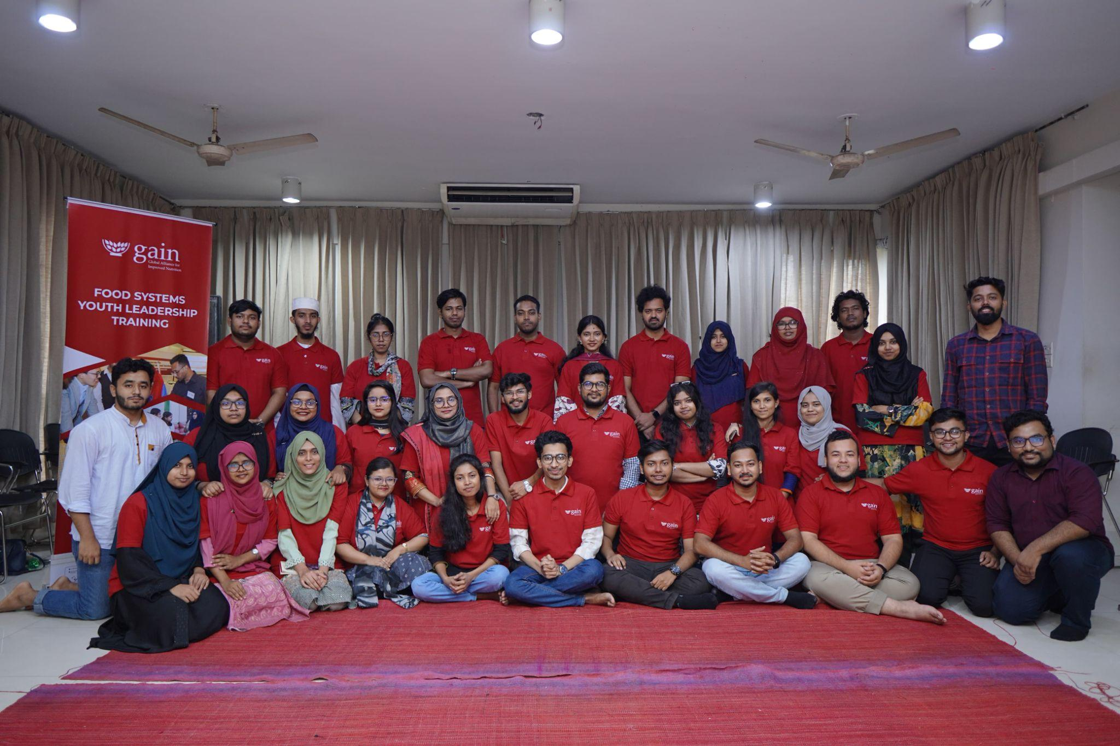
“Before the training, my approach was mostly local and focused on specific issues. But the training opened my eyes to systemic change. It taught me how to think beyond symptoms and focus on the root causes of nutritional challenges, empowering me to dream bigger for my community.”
The training equipped her with a new lens to view familiar challenges. Joya explains, “After the training, I revisited the Mirpur Buddhi Protibondhi and Autistic School. Before, I saw their need for food, but the training helped me see the interconnectedness of nutrition with their overall well-being and inclusion. I realized the problem wasn't just a lack of nutritious options, but how these options were presented and integrated into their specific needs and learning styles.”

In September 2024, Joya launched HeartWise Nutrition BD—a youth-driven platform advocating for what she calls “HeartWise Nutrition”: a culture where food nourishes both health and humanity. Her journey started with differently-abled children from Mirpur Buddhi Protibondhi and Autistic School. Many disliked vegetables. Few washed hands. But instead of correction, she chose connection. She used games, drawing, and emoji storytelling to reintroduce food as a friend—not fear. Slowly, the children responded—with smiles and bites of fruit.

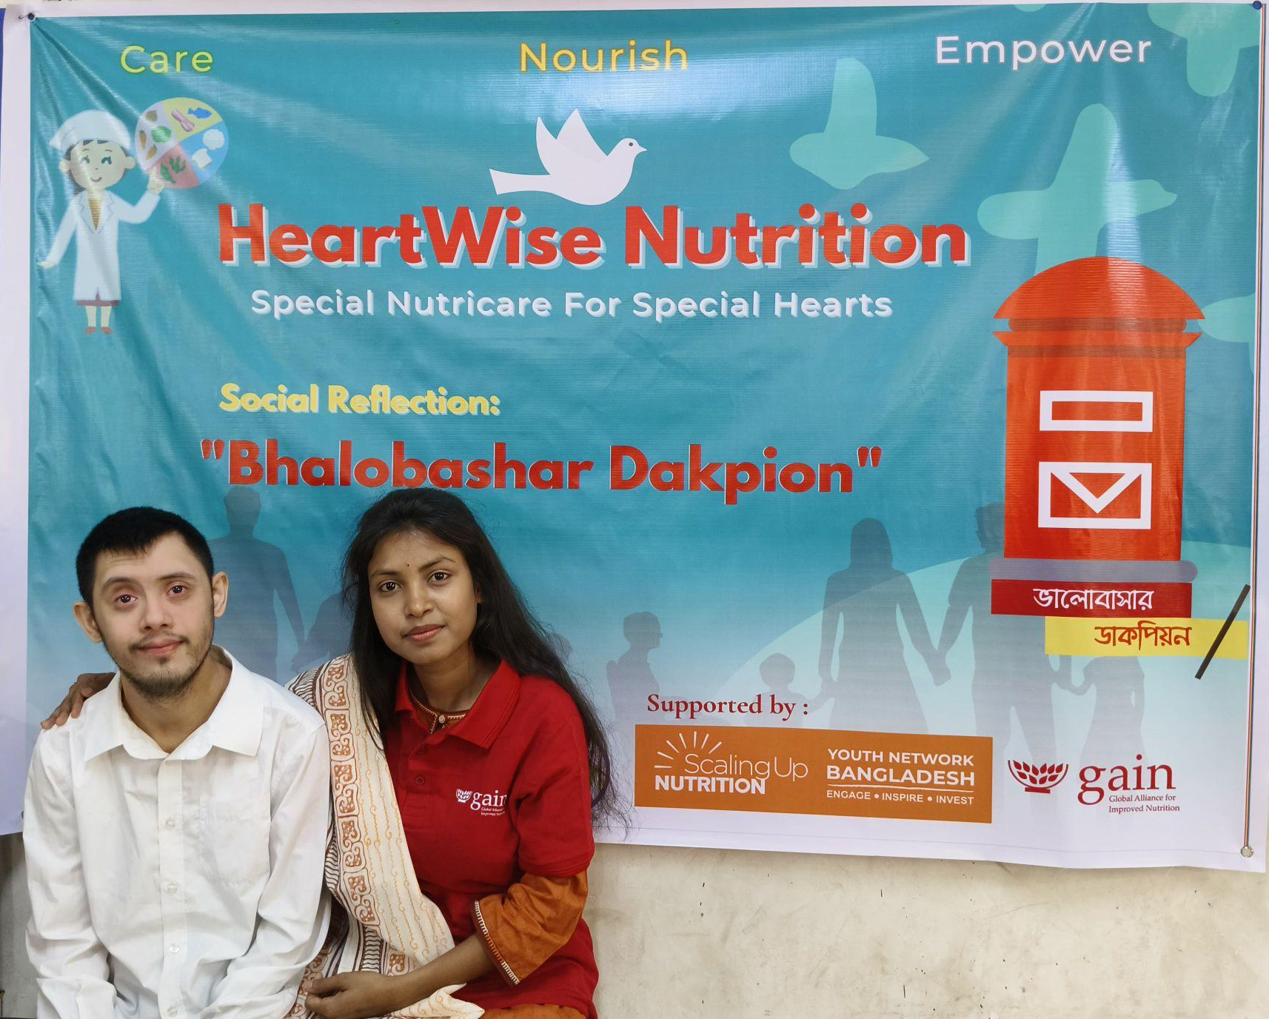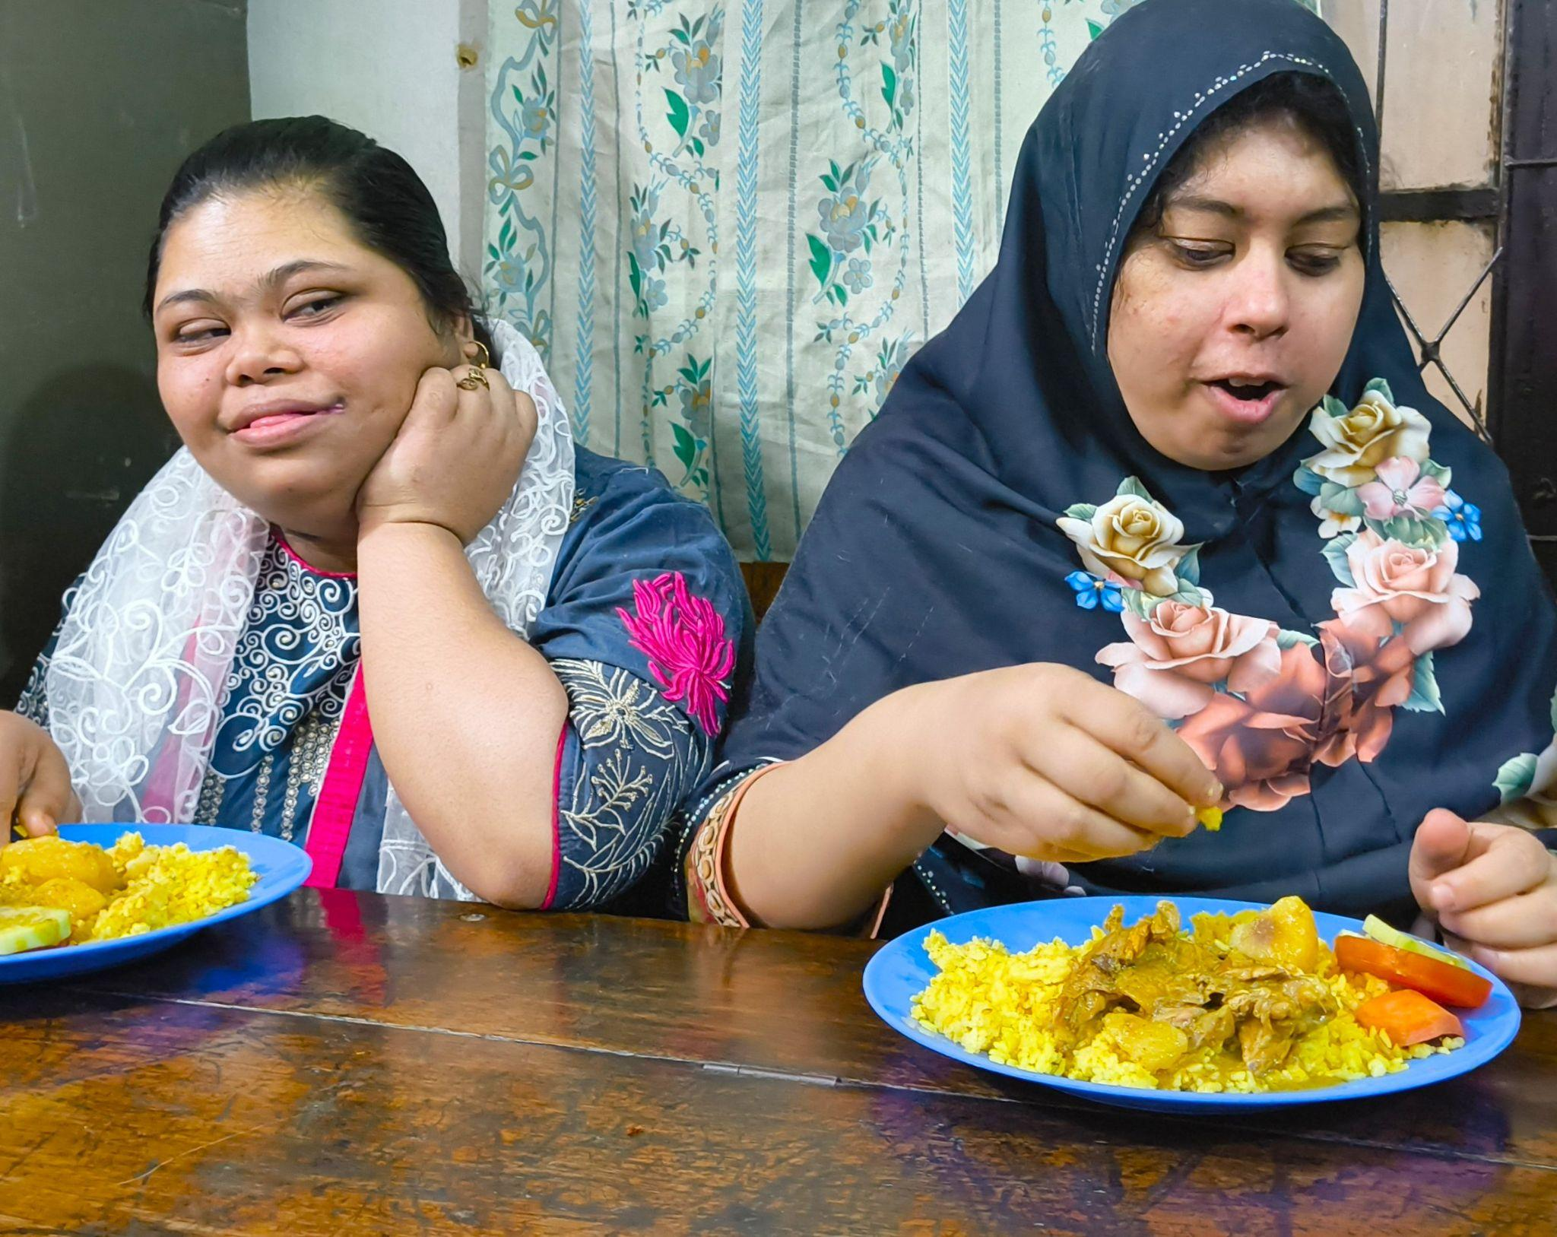

Joya reflects on this initial success, “It was incredibly rewarding to see the children at Mirpur School start exploring new foods and show more joy around meal times. When a child who previously refused all vegetables willingly tries a carrot because we made it part of a game, that’s a huge win. It proved that our empathetic, 'HeartWise' approach could make a real difference in their daily nutrition and happiness.”

Joya’s mission grew quickly. In November, she joined the National Food Systems Workshop, offering insights into youth-led action. By December, she completed the Training of Trainers (ToT)—empowering 90 new youth leaders across three districts.

In February 2025, HeartWise launched a Midday Meal Program for neurodivergent children. To reach those most often excluded, Joya organized the Pushti Bondhu Camp, a full-day initiative for 60 children with disabilities and their caregivers. Each child received a BMI check, dietary consultation, and health screening. Parents engaged in open dialogues on caregiving and nutrition. This initiative was supported by partners including GAIN, SUN Youth Network Bangladesh, Pustibid Foundation, SERAC Bangladesh, Youth Against Hunger, and JCI Dhaka Diplomats.

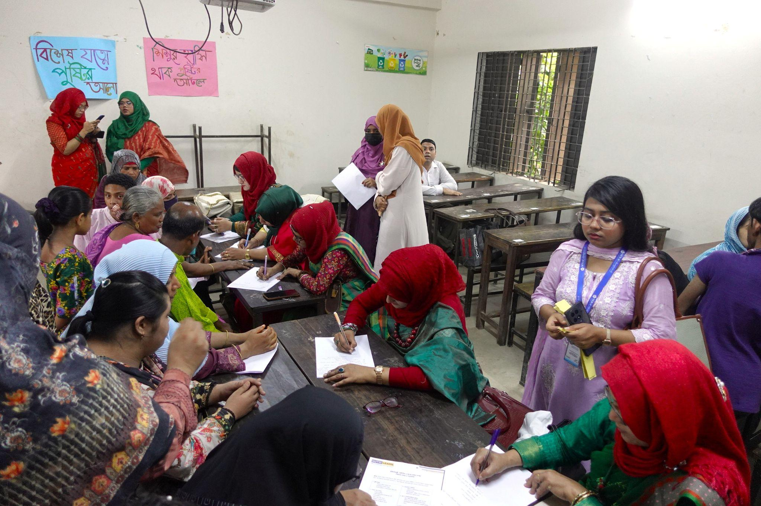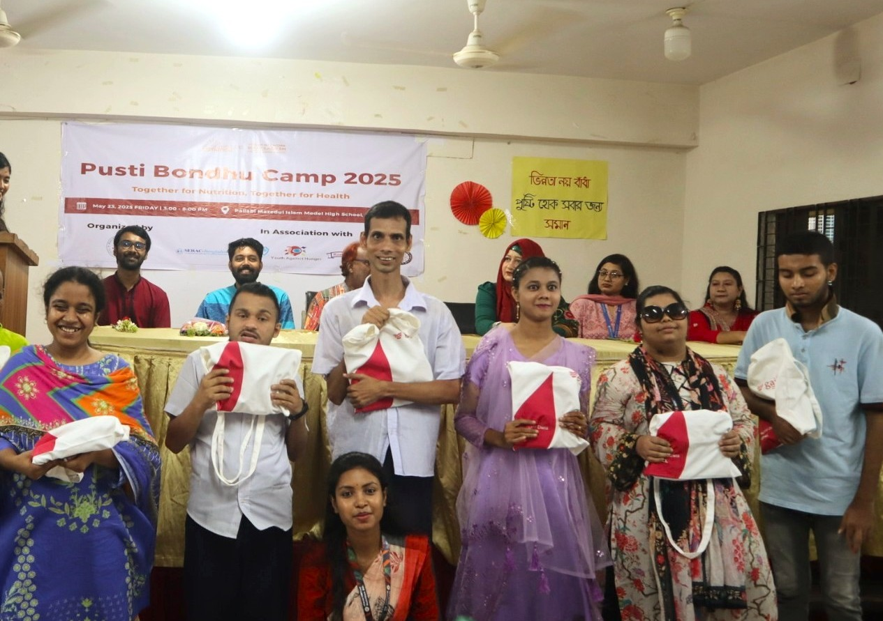

The impact is deeply appreciated by those involved. Masud Laskar, Principal of Mirpur School for the Intellectually Disabled and Autistic Children, affirmed, “Initiatives like the ‘Pushti Bondhu Camp’ are exemplary models of inclusive community engagement. Through personalized counseling, these programs help us better understand their unique nutritional needs and reaffirm our responsibility to provide the care they truly deserve."
A meaningful part of Joya’s work is shaped by her own experience growing up. During her adolescence, topics like menstruation and physical changes were rarely discussed. Many girls felt confused and embarrassed. As a result, some began skipping meals, missing school, and quietly struggling with their health and confidence.
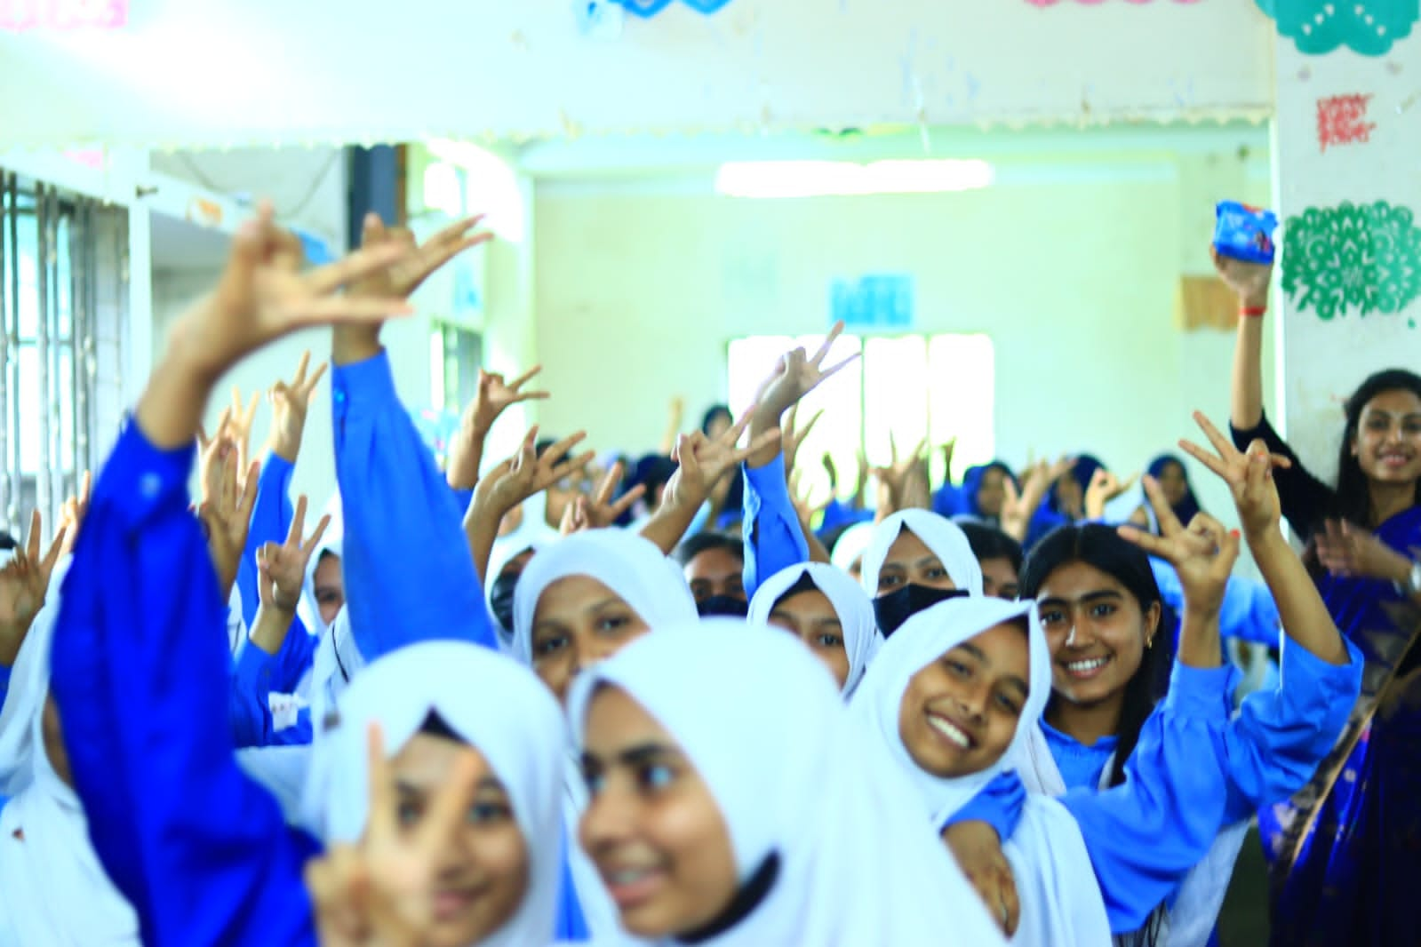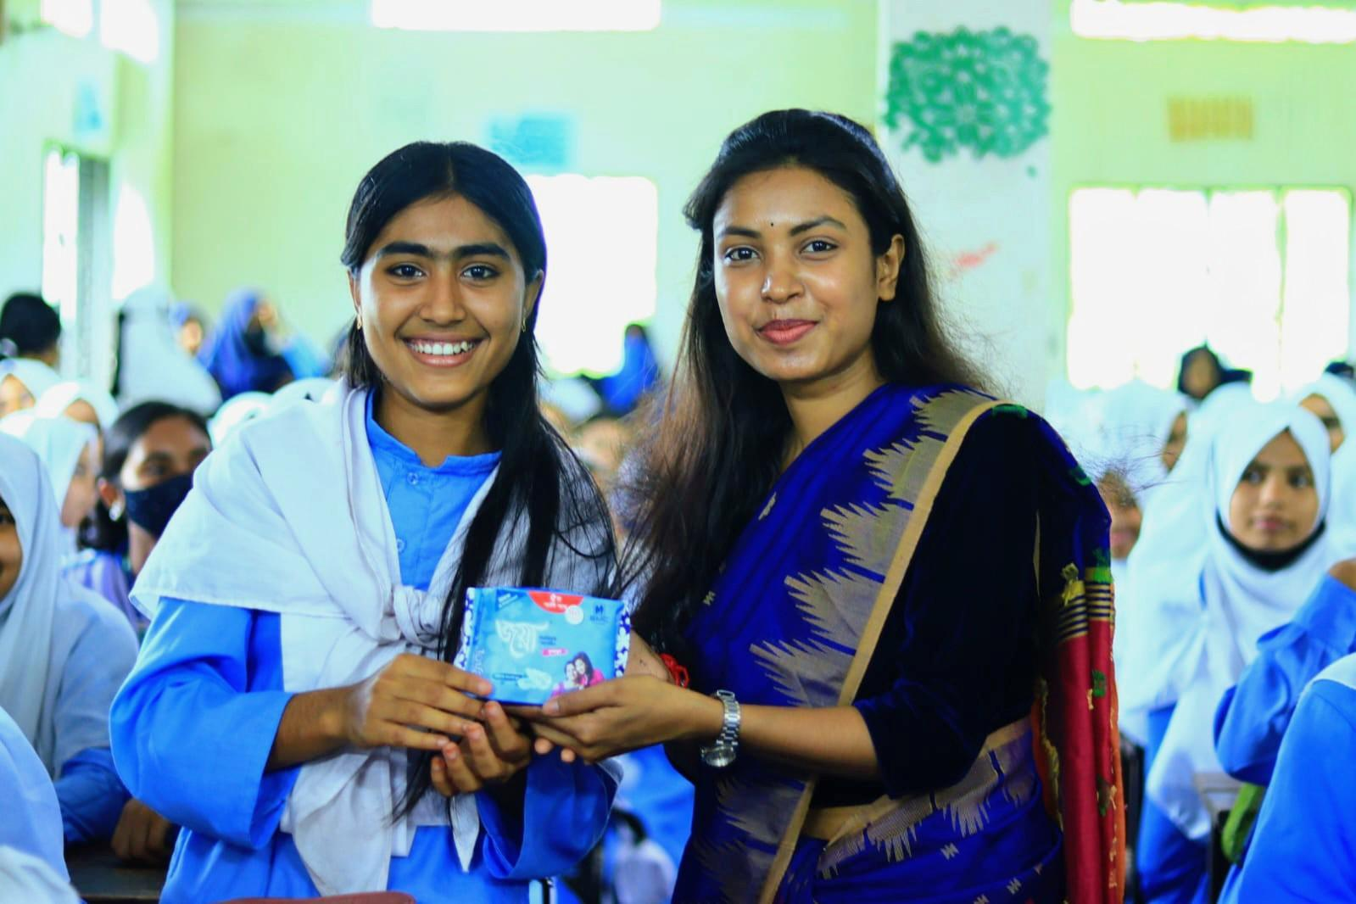
These early experiences led to the creation of Kishori Kothon—a school-based program that creates open spaces for adolescent girls to talk about nutrition, menstruation, hydration, and emotional well-being. In partnership with the SMC School Activation Program, Joya organized sessions in six schools in Shayestaganj. Girls sat in circles, shared their thoughts, and learned from each other. A total of 672 sanitary pads were also distributed, helping address a basic but often overlooked need. She hopes to expand Kishori Kothon to schools across the country so more girls can grow up informed, confident, and supported.
Mohammad Abdullah Al Mamun, Principal of Zohur Chan Bibi Women's College in Shayestaganj, praised the program: “Awareness programs like ‘Kishori Kothon, Amar Ami — Pushti Bujhi Sustho Thaki’ are extremely timely and necessary for our national development. Ensuring the physical and mental well-being of adolescent girls should be an initiative in every educational institution. Through regular nutrition, health, and mental awareness activities, our girls will become healthier, more confident, and prepared for the future. Such activities should be expanded nationwide."
Today, HeartWise is a team of 16 young people working together to promote nutrition and care in schools and communities. Her message remains simple but powerful: Nutrition is not only about food. It’s also about rights, respect, and understanding people’s needs.

